Chapter 12, Solution 12.

Using Fig. 12.45, design a problem to help other students to better understand wye-delta connected circuits.

Although there are many ways to solve this problem, this is an example based on the same kind of problem asked in the third edition.

Problem

Solve for the line currents in the Y-Δ circuit of Fig. 12.45. Take Z_{Δ} = 60∠45°Ω.

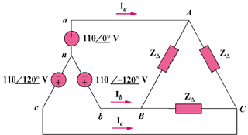

Figure 12.45

Solution

Convert the delta-load to a wye-load and apply per-phase analysis.
Z_{Y}
1100 V
+
−
I_{a}

